# Md. Sajid Ahmed

Roll – 02

Answer to the question no- 1

CSS Stand for Cascading Style Sheets.

Answer to the question no- 2

Using <link> element within the <head> section.

Answer to the question no- 3

Inside the <head> section and using the <link> element.

Answer to the question no- 4

<style> tag.

Answer to the question no- 5

Style attribute.

Answer to the question no- 6

P {

color : blue;

font-size: 16px;

}

Answer to the question no- 7

/* Insert a comment in a CSS files */

Answer to the question no- 8

Background-color property.

Answer to the question no- 9

Use style tag in the head section. Write style tag below the code:

h1 {

background-color: cyan;

}

Answer to the question no- 10

color property.

Practical

**Answer 1**

<!DOCTYPE html>

<html lang="en">

  <head>

    <meta charset="UTF-8" />

    <meta name="viewport" content="width=device-width, initial-scale=1.0" />

    <title>CSS Selectors Example</title>

    <style>

      /* Element Selector */

      p {

        color: blue;

      }

      /* ID Selector */

      #Area {

        border: 1px solid;

      }

      /* Class Selector */

      .mainArea {

        background-color: rgb(127, 127, 134);

      }

      /* Universal Selector */

      * {

        margin: 0;

        padding: 0;

      }

      /* Grouping Selector */

      h1,

      h3,

      h4 {

        font-family: Arial, sans-serif;

      }

    </style>

  </head>

  <body>

    <div>

      <h2>Element Selector Example (Text Color)</h2>

      <!-- Element Selector use for all paragraph tag -->

      <p>This paragraph used for Element Selector.</p>

      <p>This paragraph used for Element Selector.</p>

      <p>This paragraph used for Element Selector.</p>

      <p>This paragraph used for Element Selector.</p>

      <p>This paragraph used for Element Selector.</p>

    </div>

    <div id="Area">

      <!-- id selector use -->

      <h2>Id Selector Example (Border)</h2>

      <!-- Element Selector use for all paragraph tag -->

      <p>This paragraph used for Element Selector.</p>

      <p>This paragraph used for Element Selector.</p>

      <p>This paragraph used for Element Selector.</p>

      <p>This paragraph used for Element Selector.</p>

      <p>This paragraph used for Element Selector.</p>

    </div>

    <div class="mainArea">

      <!-- class selector use -->

      <h2>Class Selector Example (background-color showing)</h2>

      <!-- Element Selector use for all paragraph tag -->

      <p>This paragraph used for Element Selector.</p>

      <p>This paragraph used for Element Selector.</p>

      <p>This paragraph used for Element Selector.</p>

      <p>This paragraph used for Element Selector.</p>

      <p>This paragraph used for Element Selector.</p>

    </div>

    <div>

      <h5>Margin and padding 0 for use Universal selector.</h5>

    </div>

    <div>

      <!-- Grouping Selector -->

      <h1>Grouping Selector use (fonts)</h1>

      <h3>Grouping Selector use</h3>

      <h4>Grouping Selector use</h4>

    </div>

  </body>

</html>

**Answer 1 output**

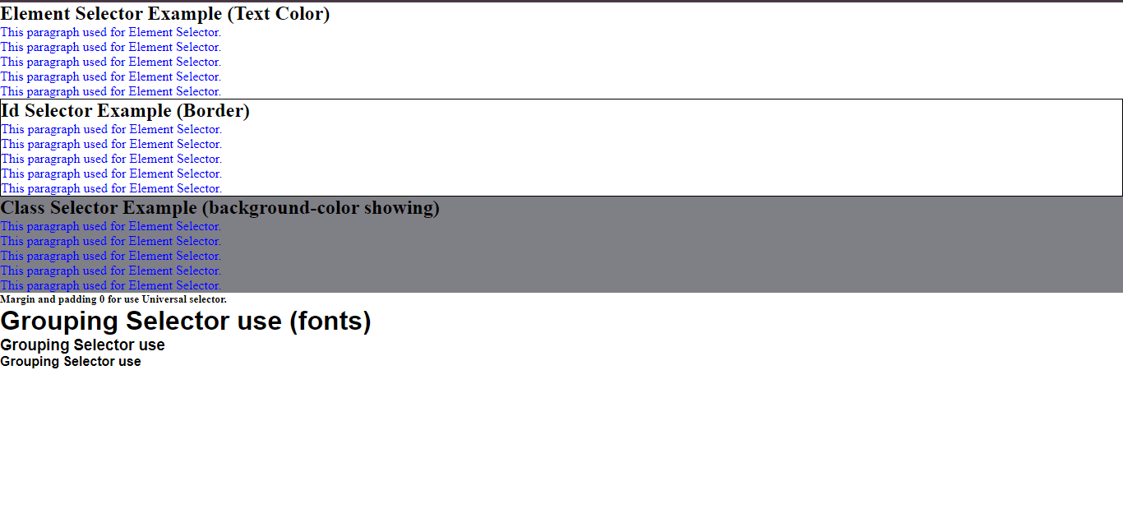

Answer 2

Below is an example of HTML code demonstrating External, Internal, and Inline CSS:

External CSS:

<!DOCTYPE html>

<html lang="en">

<head>

<meta charset="UTF-8">

<meta name="viewport" content="width=device-width, initial-scale=1.0">

<title>External CSS Example</title>

<!-- External CSS -->

<link rel="stylesheet" href="styles.css">

</head>

<body>

<h1>This is an External CSS Example</h1>

<p class="highlight">This paragraph has a class of 'highlight'.</p>

<p>This paragraph does not have any specific styles.</p>

</body>

</html>

**styles.css**:

/* External CSS */

h1 {

color: blue;

}

.highlight {

background-color: yellow;

}

Internal CSS:

<!DOCTYPE html>

<html lang="en">

<head>

<meta charset="UTF-8">

<meta name="viewport" content="width=device-width, initial-scale=1.0">

<title>Internal CSS Example</title>

<style>

/* Internal CSS */

h1 {

color: blue;

}

.highlight {

background-color: yellow;

}

</style>

</head>

<body>

<h1>This is an Internal CSS Example</h1>

<p class="highlight">This paragraph has a class of 'highlight'.</p>

<p>This paragraph does not have any specific styles.</p>

</body>

</html>

Inline CSS:

<!DOCTYPE html>

<html lang="en">

<head>

<meta charset="UTF-8">

<meta name="viewport" content="width=device-width, initial-scale=1.0">

<title>Inline CSS Example</title>

</head>

<body>

<h1 style="color: blue;">This is an Inline CSS Example</h1>

<p style="background-color: yellow;">This paragraph has inline styles for background color.</p>

<p>This paragraph does not have any specific styles.</p>

</body>

</html>